Level: 140, 214HP (un-confirmed)
Slayer level required: 72
Slayer item required: None, but Elemental Shield is highly recommended
Max Hit: 49 without Elemental Shield, 13 with it. (highest I've seen, not sure if they are max)
Drops: Granite Legs, Uncut Diamond, 2 Law Runes, 132gp, 250gp, Level 3 Clues, 60 Noted Rune Essence, Herbs, Cosmic Talisman, 10 Chaos and 30 Air Runes, Lobster (cooked), 7 Blood Runes, Black Axe, Dragon Left Half (un-confirmed), Dragon Medium (un-confirmed), Dragon Spear (un-confirmed), Wyvern Bones (50xp each, untradeable).
Misc: When you use Range armor it will use Melee attacks, when you use Melee armor it will use Magic attacks. It can also do a "freeze attack" that freezes you just like the Ancients spells. Magic apparently does not work well on them.
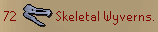
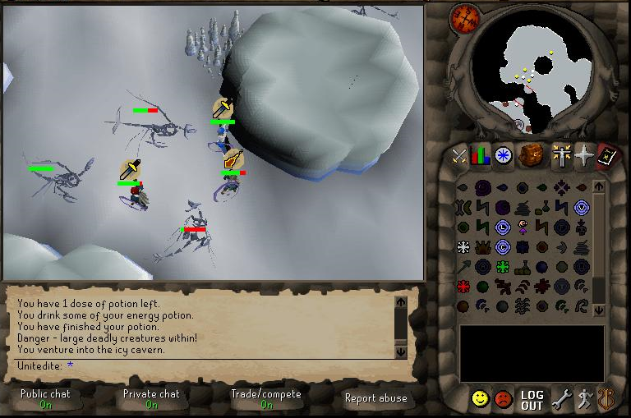
------------------------------------
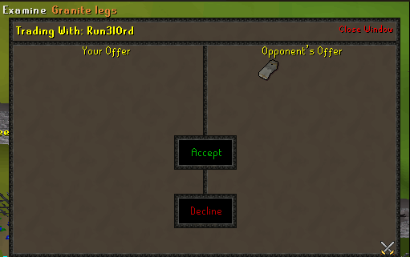
QUOTE('Granite Legs')
Attack Bonuses
Magic: -31
Range: -18
Defense Bonuses
Stab: 43
Slash: 45
Crush: 41
Mage: -4
Range: 68

